**How to use the App**

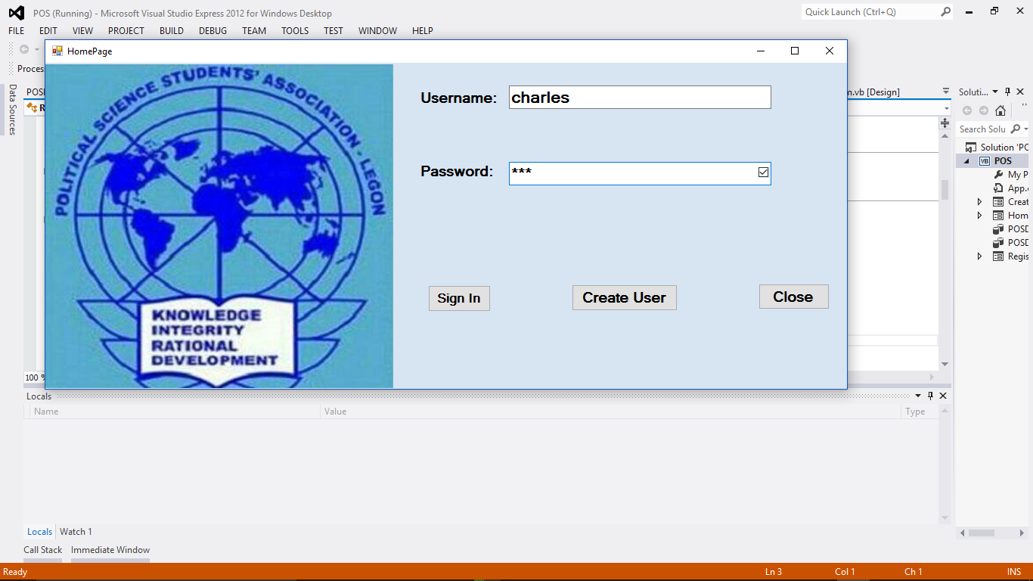

This is the Home page of the entire application, and user has to sign up first before he or she can log in using the same username and password he or she signed up with but in other to secure the app, it is advisable for the one user since is a monitoring app. After entering the username and password, then you click on the Sign in button to proceed to the main form that is the registration app…

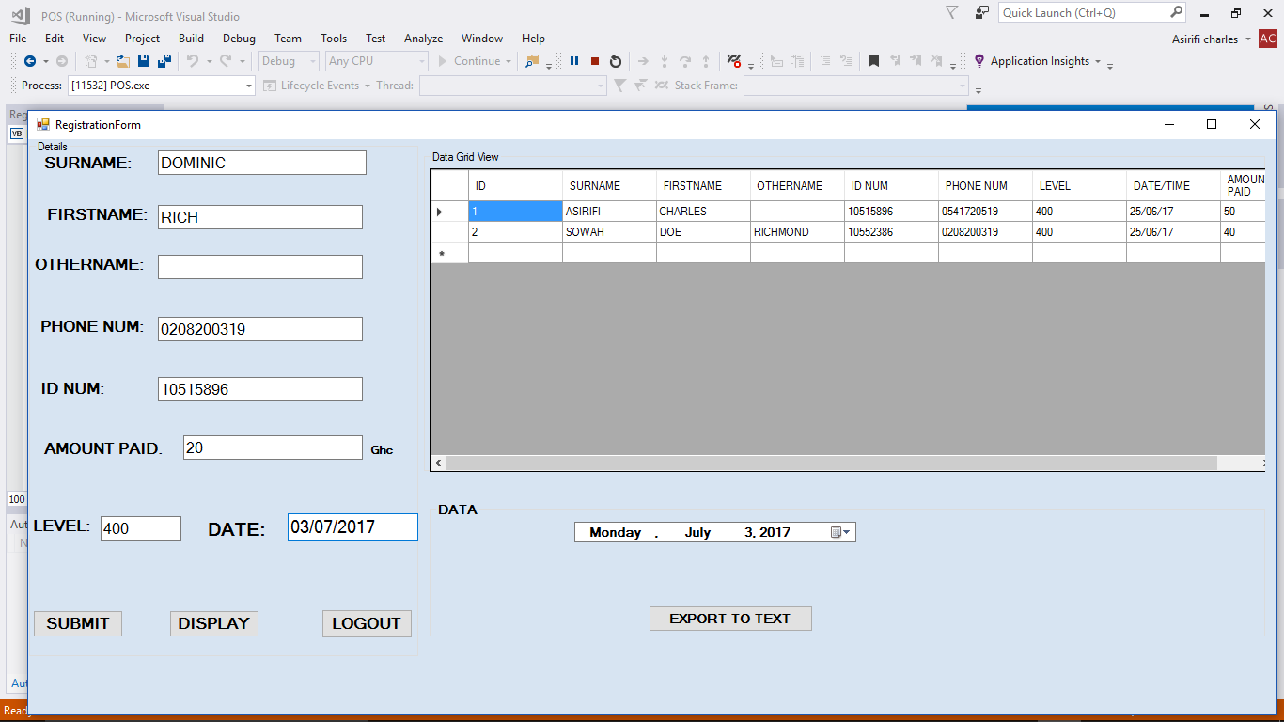

This is the second page of the app and it is the main page that takes information of the user and stores it in the database of the application. Please make sure to enter all the information into the textbox with capital letters and fill all the information (last name is optional so you can leave that box empty).

Phone number should be 10 digit as you can see from the picture below and index number should be 8 digit numbers and no letters please. Amount paid should be numbers. When you are convinced enough the information been entered , then you click on the submit button to send it to the database . You can view all the information that is in the database by clicking the display button and seeing the result on the datagrid view side ….

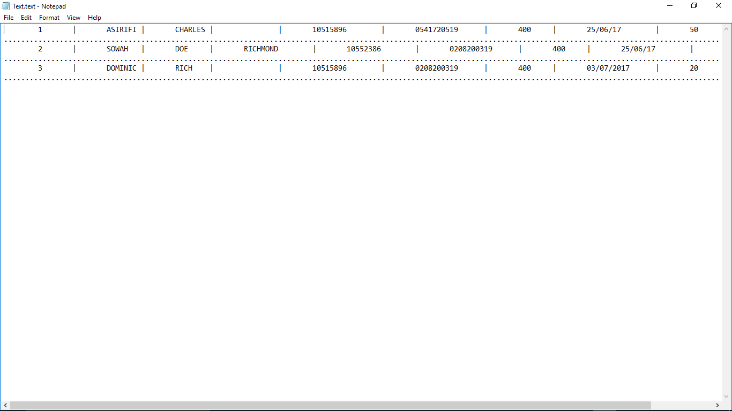

The export to text button generates text document with all the information from the database in a text form for the user to see and print it or save it for future reference. Because of the live view of the database, I didn’t add any search button on the form. Text document can be found in the folder called **text Generated** when user clicks the POS app folder. You can further select and paste it in word and print it…